AUTOMATIC DARKENING WELDING HELMET
User’s manual of series

User’s manual of series

Pay attention to self-safety and read this manual carefully while installing and operating this product

1、General
The liquid crystal light valve(LCLV) in this product can turn from light to dark at the moment of electricity arc appearing,with the principle of photoelectric.The darkness degree can be adjusted between DIN 9 and 13.UV-IR filtering assembly consists of reflective coated glass,multi-layer light valve(LCD)and polarizer.It can effectively block the ultraviolet radiation and infrared ray from get through ,then effectively protect the eyes of the workers against the dama-ges of ultraviolet radiation and infrared ray.Automatic darkening helmet has wider coverage than common helmet.It can be used to protect the face and neck against the damages of the electricity arc and improve the product quality and working efficiency.This product is widely used by many developed countries at present.
This product is widely used in shipbuilding,petroleum,
Architecture,steel,boiler-manufacture and so on .The working temperature range is -5℃~+55℃.The limited working temperature range is -10℃~+60℃.The limited storage temperature range is -20℃~+70℃.The relative humidity range is 20%~80%.
2、Working Principle
The helmet can converse the electricity arc resulted from welding to the electronic signals.And after these signals are magnified,they will be passed to the LCD driven circuit,in which the light valve will be turned from light to dark.So that can avoid the damages to the eyes of the workers.
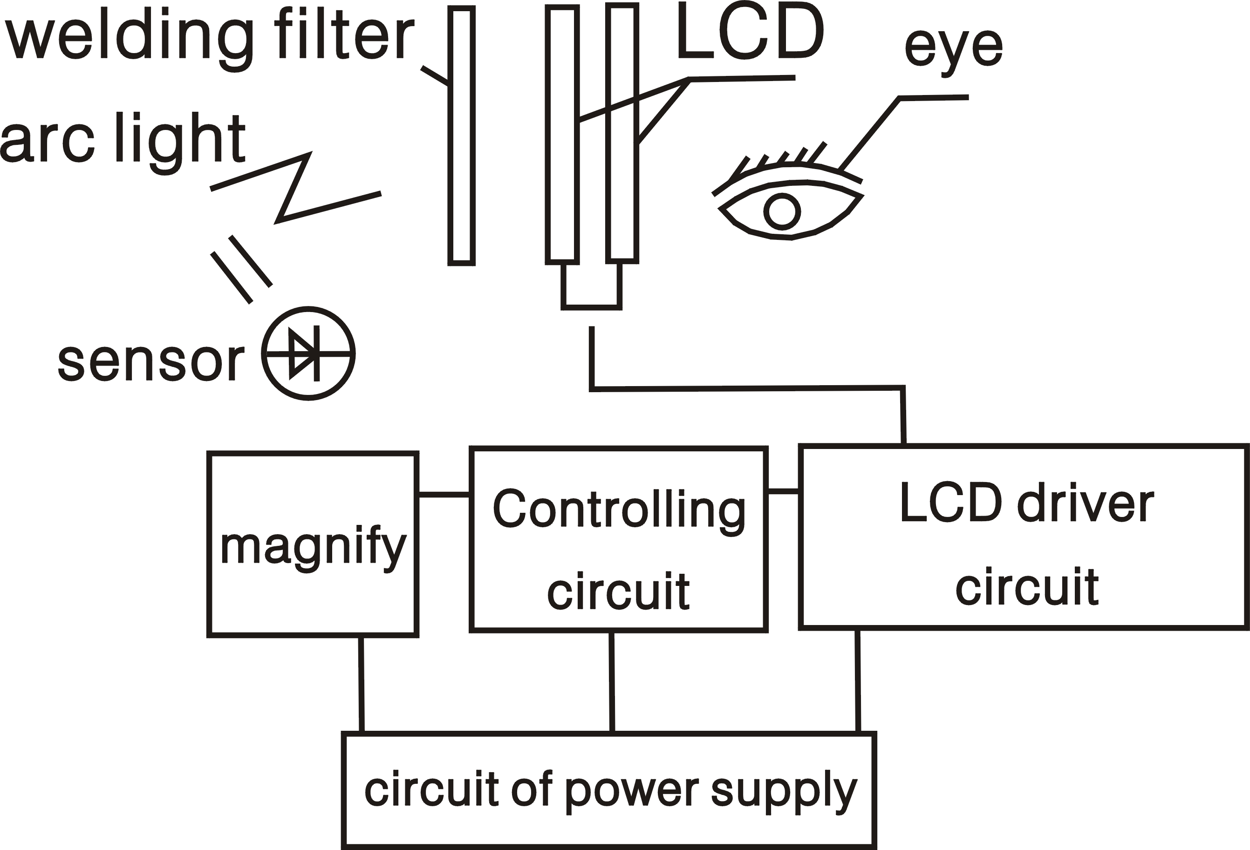
The principle of the whole circuit is as follows:

3、Main Technical Index and Parameter

Type | Power Supply | Cartridge Size | Active Viewing  Area | Light Shade | Dark Shade | Way to shift dark state | Switching time | Delay Time | Sensitivity Adjustment | Delay Adjustment
WS  1000 | Lithium battery/  solar powered | 110mm×90mm | 93mm×43mm | DIN4 | DIN  9-13 | Outer Control,stepless shift | 1/25000s | 0.1~  0.8s | Stepless Control | Stepless Control
WS  200 | Lithium battery/  solar powered | 110mm×90mm | 88mm×30mm | DIN4 | DIN  11 | × | 4/10000s | 0.2s | × | ×
FS | Lithium battery/  solar powered | 108mm×500mm | 88mm×34mm | DIN4 | DIN  11 | × | 4/10000s | 0.2s | × | ×

4、Size of the helmet
The sketch map of automatic darkening welding helmet is as follows:

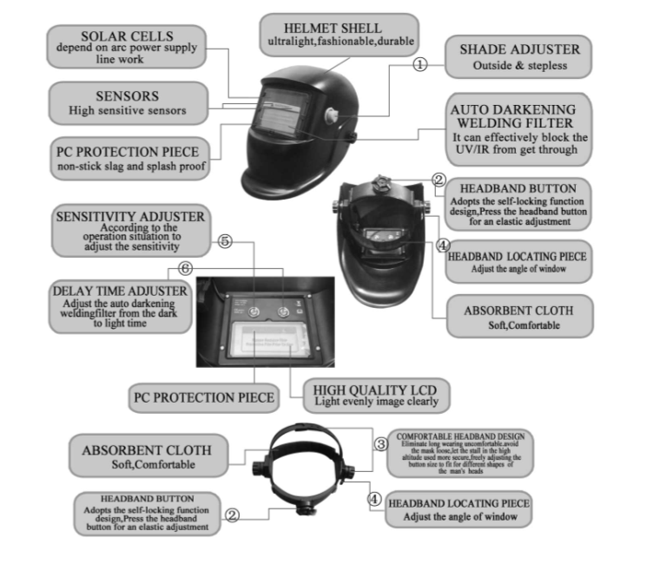

- Operation instruction
（1）、Open the package and take out the helmet.Tear off the protective film of the viewing area.Then exam whether every parts is good enough(the lithium battery is installed before delivery).
（2）、Adjust tightness of the comfort cushion through the manual knob in order to make the user comfortable after wearing it.Adopts the self-locking function design,Press the headband button for an elastic adjustment。PICTURE: ②
（3）、Adjusting the knobs on the sides of the helmet is to change tightness when lifting the helmet up and down.Visual angle can be moved it ahead and backwards to fulfill the user`s need.PICTURE:③④
（4）、Adjustable sensitivity and delay time of the viewing area enable the user to adjust according to different working condition.Reduce the sensitivity to avoid interference.When small current low arc is used ,high sensitivity can be selected. But high sensitivity must be adopted in case of argon arc.Delay time means the time from dark to light of the filter。
PICTURE:⑤⑥
（5）、According to strength degree of electricity arc,we can adjust the knobs to fulfill the user`s needs to different shade.Outside&stepless。PICTURE:①
（6）、When the filter doesn`t work or NO.of the light-shade is out of service,we should exchange the battery.
6、Maintenance
Please pay attention to the daily maintenance in order to prolong the life.
(1)、Make no water enter into the product,or it will cause permanent damage.
(2)、Don`t expose the product under the sunshine.
(3)、Use balanced strength to adjust the electrograph.Please don`t rotor it hard.
7、Storage and Transportation
Please handle the product light during the transportation.The storage temperature range is-20℃~+70℃.
8、After service
If there are any quality problems of the product in the conditions of within 18 months from date of delivery,the application of customer meeting to USER`S MANUAL`S requirements and correct using,our company guarantees to give free repair or free replacement.
9、Notification to customer
Dear Customer:
To protect our environment,when our product and its battery are in their ending life, please help us to callback the product and thecomponents.As for the unrecalled ones,please deal with properly.
Thank you very much for your cooperation and support!

